The importance of a Pedigree
With the Blackpool show fast appraoching, I thought I would pen my thoughts and experience on buying pigeons and the importance of a good pedigree. I may still be very young in terms of age compared to the average fancier at 30 years old, but I have been involved in the sport for 25 years. I’ve also been spending money on pigeons for as long as I have had money in my pocket. These are only my experiences but if I can help just one fancier and save them money or time then it will be worth while.
BUYING
Buying new pigeons for most fanciers, myself included, is one of the most exciting parts of the sport. The illusion that you have just bought a pigeon that will breed you many winners is very satisfying. The reality is the chances that you have bought nothing more than a “feeder” is very high!
I think one of the first mistakes a fancier makes, especially in the UK is that they give expensive pigeons far too much credit before its bred a single youngster. Especially pigeons bought online, with an amazing pedigree. Thousands of pounds are spent online, but would you buy a car, furniture or even a house just based on one or two pictures? I myself have fallen into this trap in the past. I would never name names, but I paid a massive amount of money for a daughter of a great racer in Belgium. It became probably the worst breeder I have ever owned. I knew after the first round was bred, but I still persisted for 2 season’s with a pigeon that had no breeding value becuase of the pedigree and the price I paid. I ended up wasting 2 seasons with good breeding cocks as a result, which was more costly than the price I paid for the pigeon. Years previously we paid the small sum of £35 for a daughter of another famous racer from Wales and within 2 years this hen had bred me 2 National winners. It just shows that you don’t need to spend a fortune to obtain good pigeons. I think its one of the main reasons I feel in love with the sport. You don’t need the deepest wallet to be at the top of the game. It makes pigeon racing very unique. All you really need is good pigeons. But finding them is the difficult part. If you could tell a good pigeon by looking at the eye, wing, colour, throat etc then it would make life much easier, and save a lot of money!
The are several ways fanciers improve the quality in their loft (or weaken if you go to the wrong address).

Stock Pigeons
Buying new stock is a huge (and exciting) part of the game. Some people buy at auctions and have great success, but If buying new stock I prefer to buy youngsters in September from fanciers who have performed well for many years. They generally have late breds from their best stock pigeons if you contact them early enough, and a young stock team I believe is of great value. A massive selection of my best pigeons over the years have come from two yearlings paired together. One tip if maybe funds are a little low at this time of year with Christmas approaching, if available take the youngsters off the best racers rather than the breeders. At some lofts the youngsters from the racers are cheaper, and of course these are the fanciers future breeders. Eggs could be even better (maybe even free!!) if you have pigeons paired the same time and the fancier is going to throw them out anyway. So in some cases you can get a youngster from a future star racer for very little money! As mentioned online auctions are also a huge part of the off season with many sites and many auctions. Most of the auctions are selling old pigeons that have been tried and tested and proven useless at stock. Save your money. The sport is expensive enough without wasting money on pigeons that are 3 or 4 years of age with zero breeding or racing results. This is just my opinion but always go for youngsters unless it is an entire clearence sale containing ALL the pigeons. There are always exceptions or course.
Racing Kits
Another option is buy some youngsters and race them. The main drawback with this method is it tends to be more expensive, depending how many youngsters you buy. But in reality its probably the best method. Rather than having to wait two years to find out whether a pigeon is good or bad, you find out much quicker. Most will be bad, but you find the good ones very qucikly and they can then be moved to the breeding section. Wolfgang Roeper in Germany is an example of this. He has bought pigeons and raced them from many fanciers with great success. Maybe the most famous example is the newly named “Olympic Leo”. Bred by Leo Heremans, raced by Wolfgang and now the property of Hans Eijerkamp for 60,000 euros. In the UK a fancier will generally want to keep the first two rounds for himself and the third round maybe too late to race. If you travel to Belgium and want to try this method then the sprint fanciers in Belgium race early, and you can sometimes buy their second or third round youngsters in March / April and get them through the darkness. Go to the sprint fanciers and study the results you can find a good name for very little money. I did this myself in 2017. With a friend we bought a large kit of youngsters from a small loft in Belgium. As it turned out they raced very well and contributed to us winning the South West Glam Fed Young Bird Averages 2017. Two nest sisters in paticular raced extremly well. You don’t need to go to Belgium to get good pigeons, even better go to a top local fancier and try and twist his arm for 6-8 youngsters to race! My one rule if I do buy some youngsters to race – don’t get many from loads of different sources. Get a few from one loft, if you buy from several your probably bringing in loads of youngsters with different levels of immunity etc. And the chances in my opinion would be increased risk of Adeno virus.
Pedigrees
How important is a pedigree when buying a new pigeon? In the example above, the pigeon I paid great money for had a very long computerised pedigree with plenty of detail. The second example was hand written with little detail. But what was important was both came from a line of winners. And that is important. You should buy off winners or from as close to the winner as possible (preferably direct). I think a pedigree is important and of great interest, but not as important as people think. The basket is always the true judge. If only the pedigree could be entered to the race there are some fanciers at the bottom of the result sheet every week who would instantly be the best. A strain or a name is also a big fasination to some UK fanciers. They must pair a Soontjen to a Soontjen. This used to make me laugh even when I was younger. It makes no sense. I always used to hear it at auctions when I went with my Dad. A fancier had spotted a Soontjen hen they wanted for their Soontjen cock. In some cases they wouldn’t even handle the pigeon. Yet a few centimetres away there could be a hen with 5 first prizes yet no intersted was given as it didn’t have Soontjen blood. I still struggle to find the logic in this way of thinking.
Good luck to all fanciers with their new purchases for 2018!
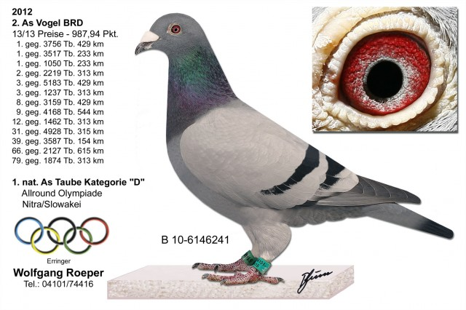
“Olympic Leo” of Roeper, previously named “241”. Watch out for pigeon names some famous pigeons have been re-named several times.

